ABILITY360.ORG | 602 .386.4566
5031 E. Washington St., Phoenix, AZ 85034

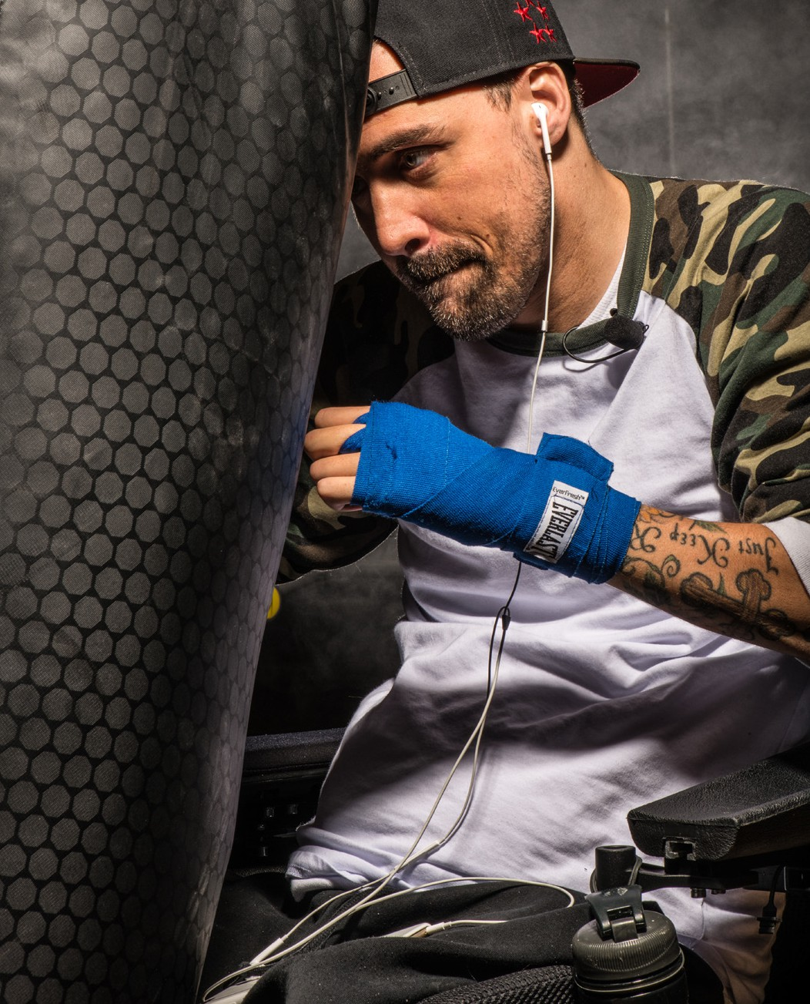
SPORTS. FITNESS. RECREATION.

HOURS
Weekdays – 6:00 AM to 7:30 PM Saturday – 8:00 AM to 2:00 PM Sunday – CLOSED

AQUATIC CENTER HOURS
(Hours vary per month, March through November)

OUR MISSION
To provide exceptional adaptive sports, recreation, aquatic and fitness programs that promote the independence, health, and overall well being of people with disabilities and their family members.

ABILITY360 SPORTS & FITNESS CENTER
Opened in 2011, the Sports & Fitness Center is a program of Ability360, a 501 (c)
(3) nonprofit organization and the largest Center for Independent Living in Arizona. Persons with disabilities and their families can purchase memberships.

Amenities include:
- Sport courts
- Cardiorespiratory equipment
- Strength equipment
- Aquatic center with lap pool, therapy pool and whirlpool
- Indoor track
- Rock climbing wall
- Accessible locker rooms, showers and dressing areas
- Event rentals

PROGRAM EXAMPLES

- Rock Climbing
- Group Classes
- Adaptive Sports
- Swim Lessons
- Aquatic Classes
- Youth Programming
- Personal Training
- Recreation Therapy

